Aditya Vibhute
25102B2002
CMPN – B

Project Topic: -
Al Powered Resume Screening System

Step 1: AWS S3 Bucket Setup
Two S3 buckets are used in this project:
• ai-resume-screener-aditya/resumes/ — Stores uploaded PDF resumes
• ai-resume-screener-aditya/results/ — Stores processed JSON results

First S3 Bucket — resumes/ folder
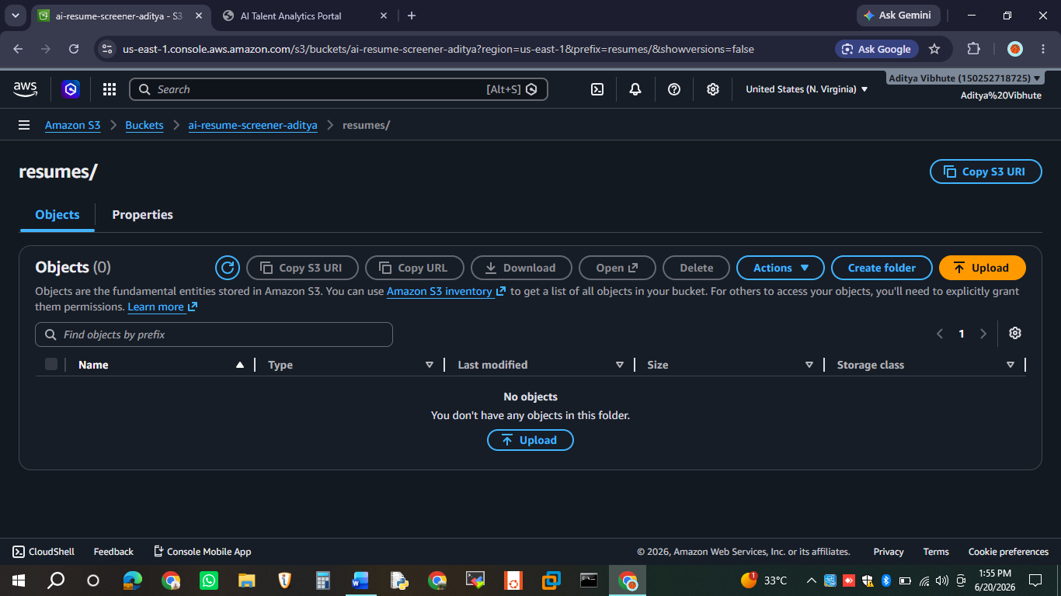

The resumes folder contains all uploaded candidate PDF files. When a new PDF is uploaded via the portal, it is stored here and automatically triggers the Lambda function for processing.

Second S3 Bucket — results/ folder
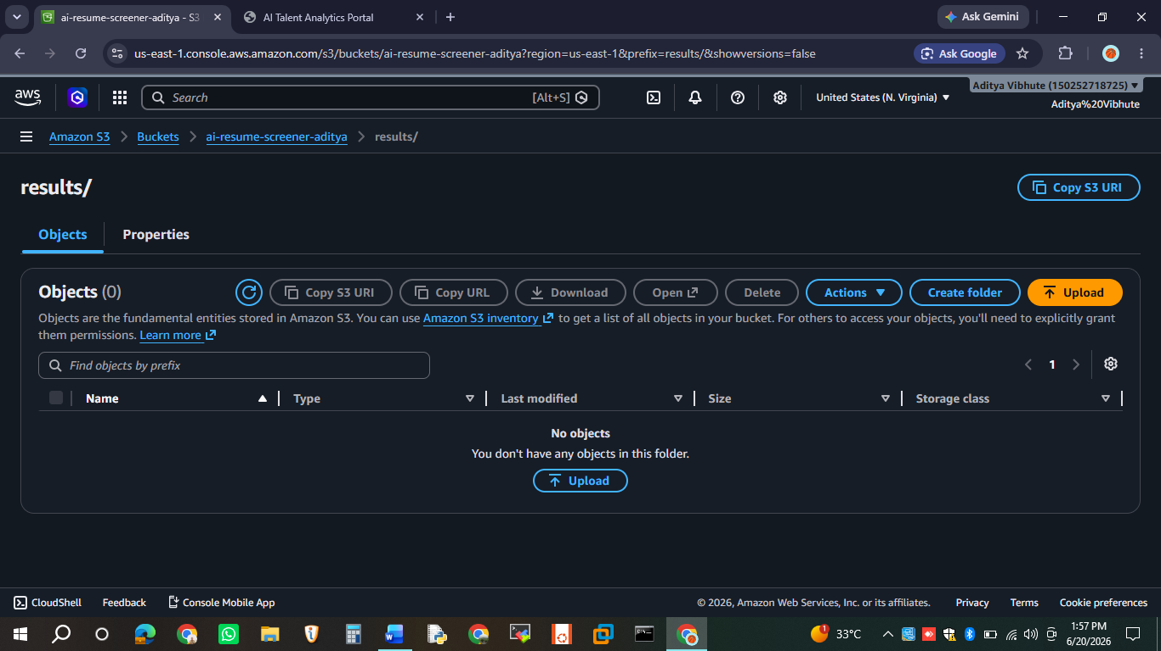

The results folder stores the processed JSON output for each resume. Each JSON file contains the candidate's name, email, role, skills, match score, and status.

Step 2: TalentScout Enterprise Portal
The portal is hosted on AWS S3 as a static website and is accessible via:
• S3 Website: http://talent-scout-portal-aditya.s3-website-us-east-1.amazonaws.com/
• GitHub Pages: https://adityavibhute18-star.github.io/talentscout-enterprise/

Upload Interface
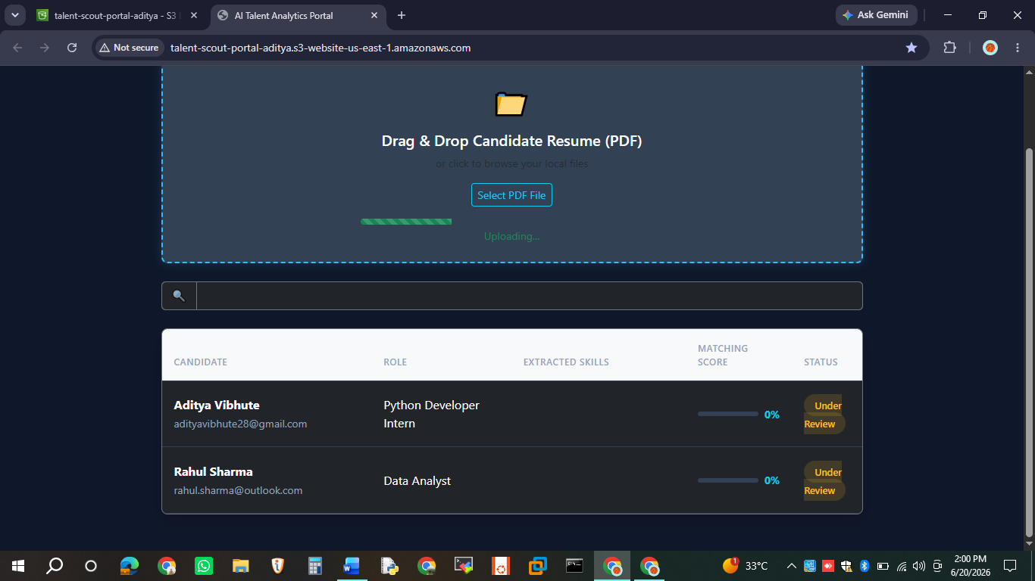

The portal features a clean dark-themed interface with drag & drop PDF upload. Users can either drag a resume onto the upload zone or click "Select PDF File" to browse and select a file.

Step 3: Resume Upload Process

Uploading Aditya Vibhute's Resume
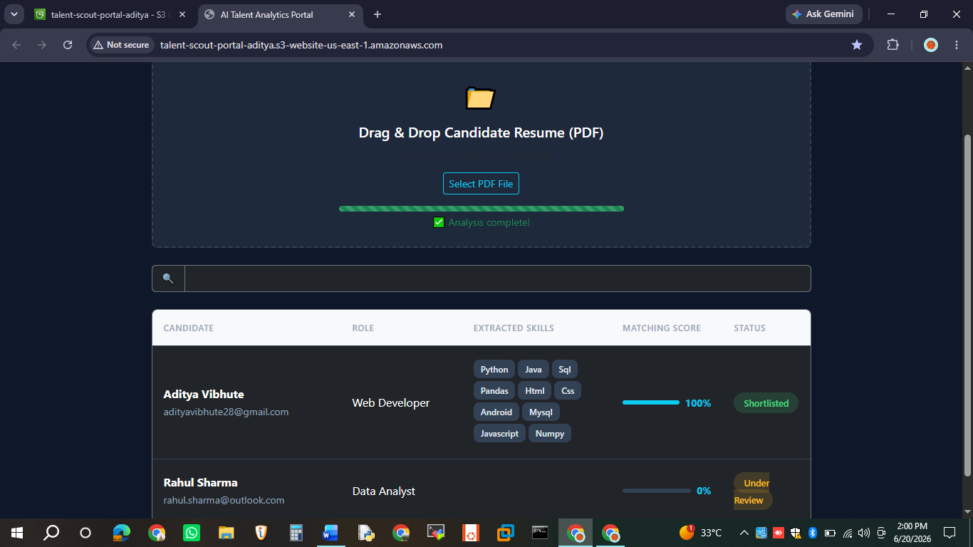

When a PDF is selected, the system:
• Calls the get-s3-upload-url Lambda to generate a presigned S3 URL
• Uploads the PDF directly to S3 using the presigned URL
• Shows a progress bar and "Analysis complete!" status
• Automatically polls S3 for the processed results JSON

Email Notification — HR (Spam Folder)
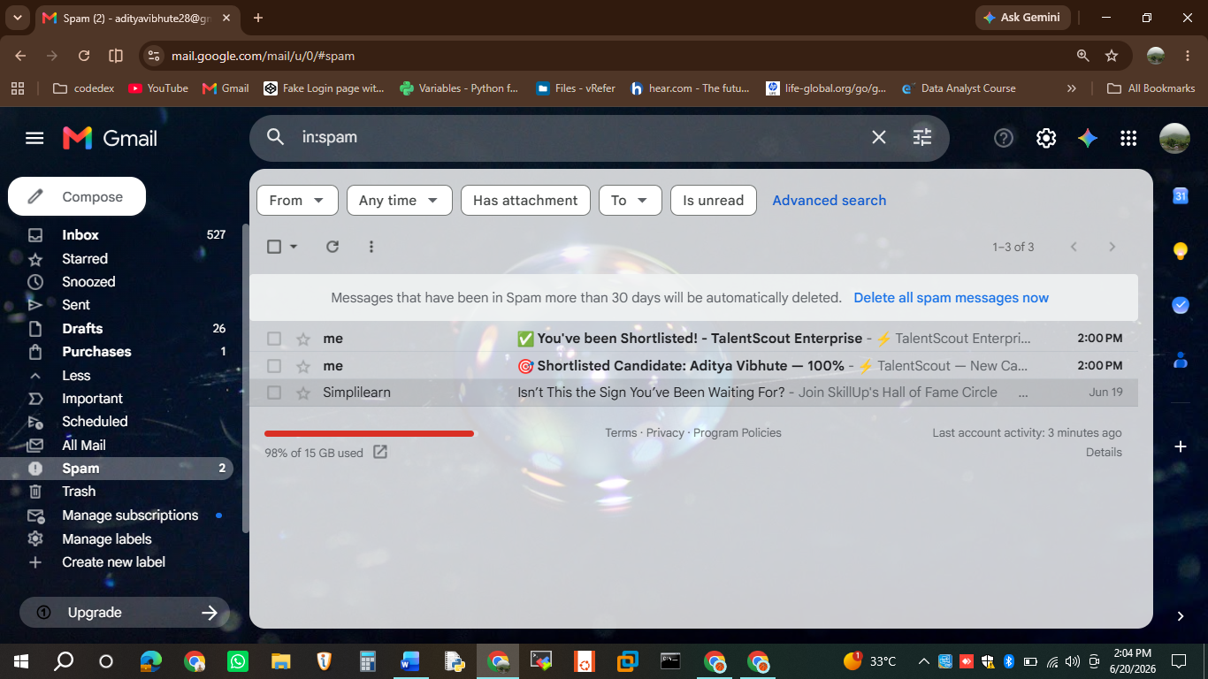

After processing, an automated email is sent to the HR email address. Note: AWS SES emails may initially appear in the spam folder. The email contains the candidate's name, role, match score, skills, and status.

Step 4: Email Notifications

HR Email Notification
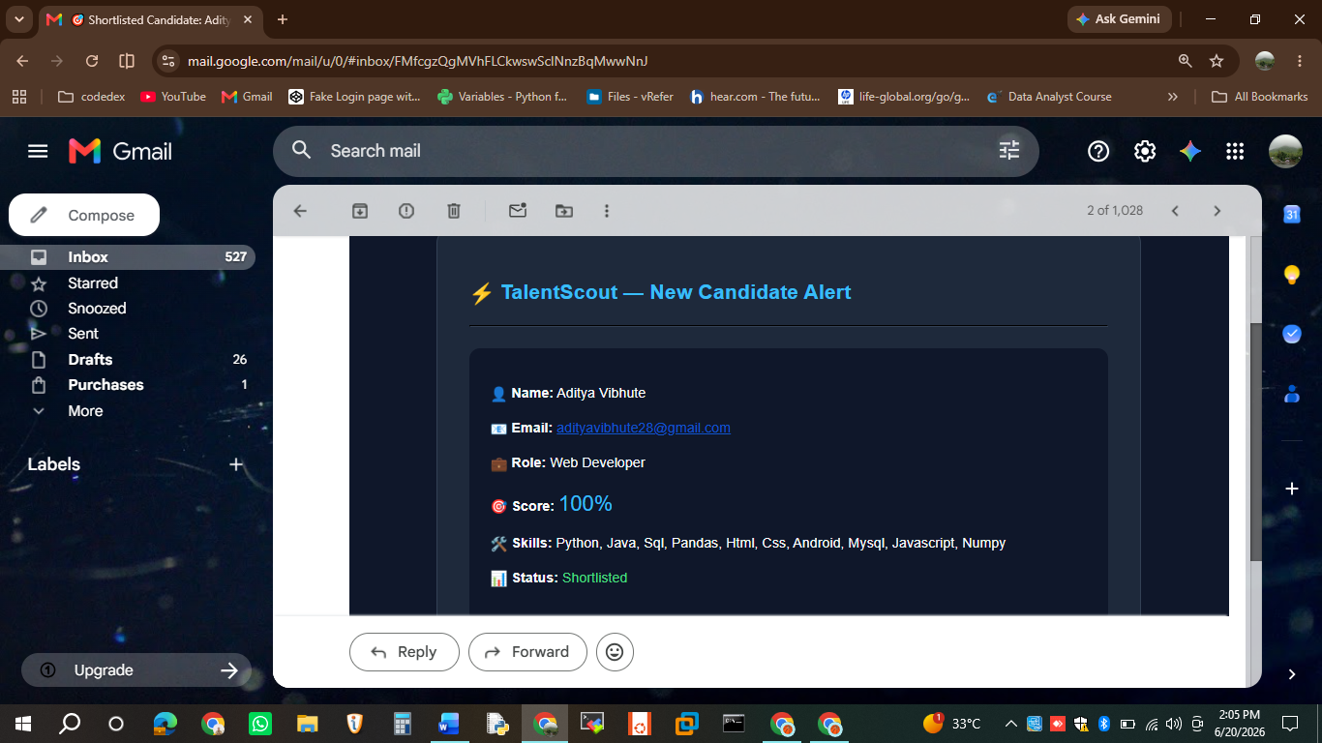

The HR notification email includes:
• Candidate Name and Email
• Best matching Job Role
• Match Score percentage
• List of detected skills
• Status: Shortlisted or Under Review

Candidate Email Notification
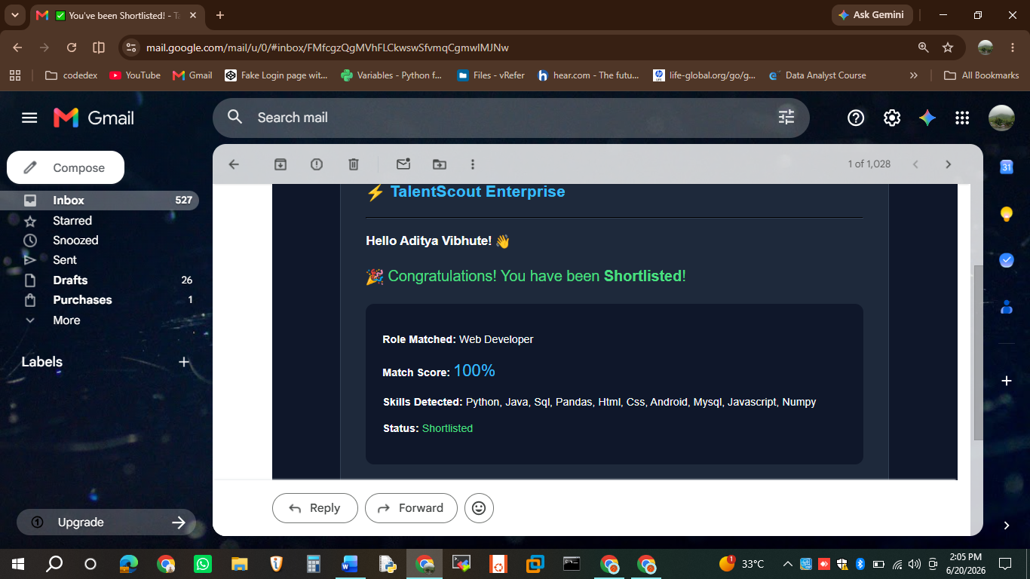

Candidates receive a personalized email informing them of their application status. Shortlisted candidates receive a congratulations message, while others receive an "Under Review" notification.

Step 5: Processing Multiple Candidates

Rahul Sharma — Data Analyst
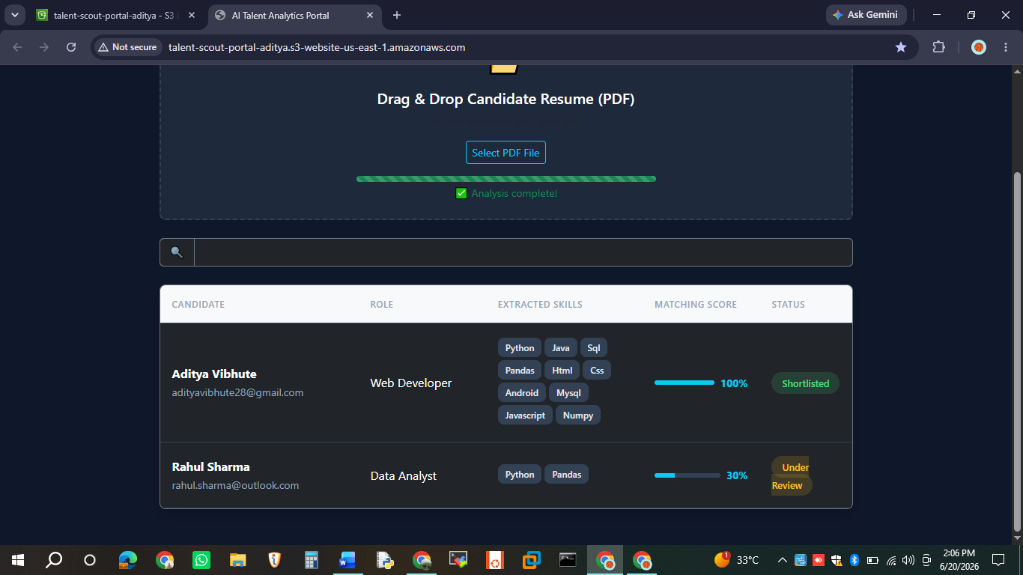

Rahul Sharma's resume was processed and matched to the Data Analyst role with a 30% match score. Skills detected: Python, Pandas. Status: Under Review.

Email to Other Candidates
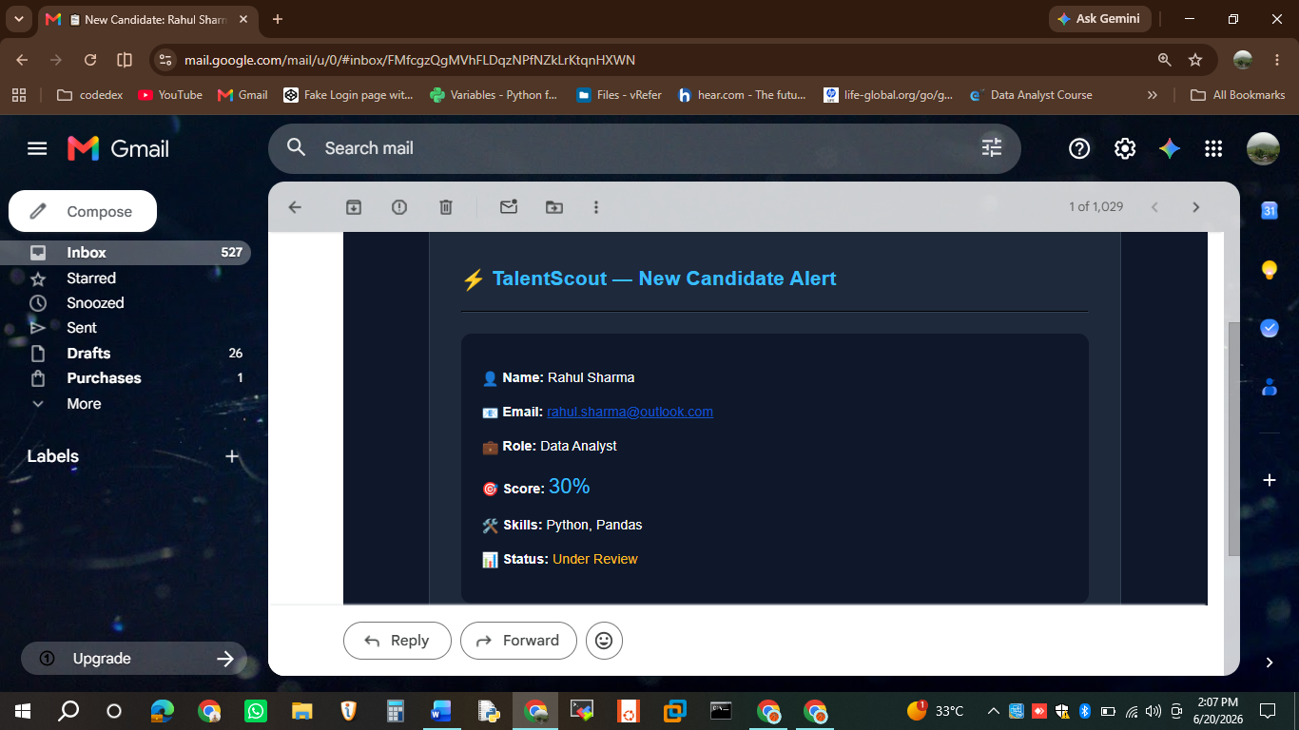

Note: In AWS SES Sandbox mode, emails can only be sent to verified email addresses. Production access has been requested to enable sending to all candidate emails automatically.

Step 6: Additional Candidate — Rohit Shamra
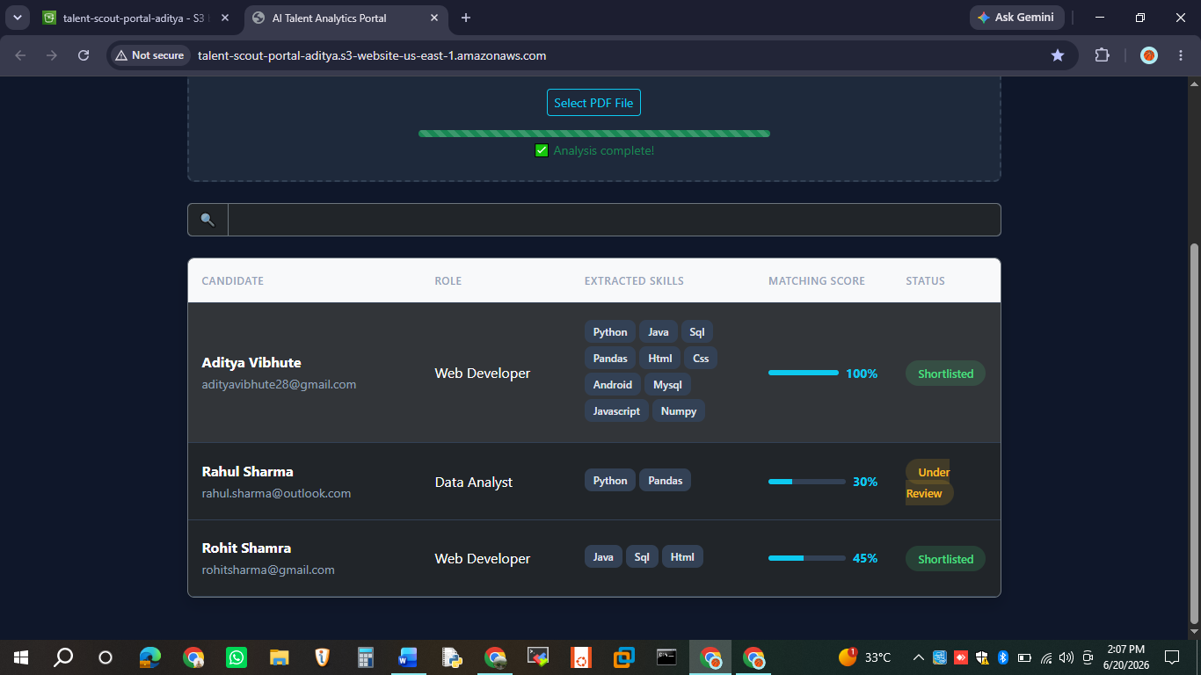

Rohit Shamra's resume was successfully processed with the following results:
• Role: Web Developer
• Skills: Java, SQL, HTML
• Match Score: 45%
• Status: Shortlisted

Step 7: Single Resume Upload Recommendation
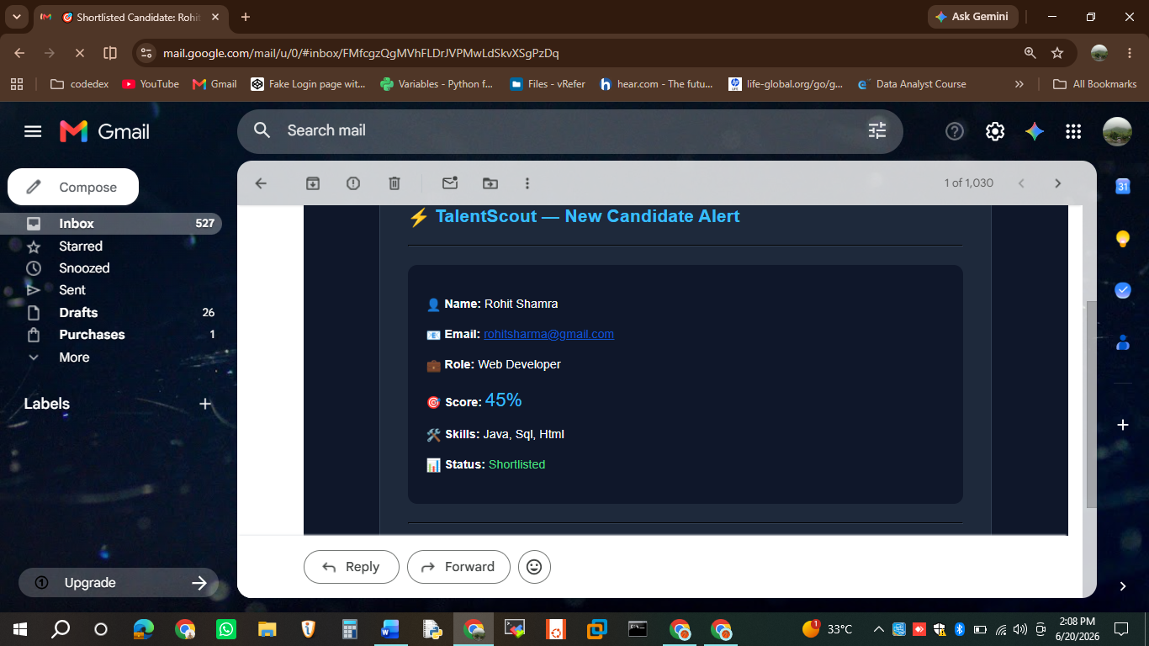

For best results with the Gemini AI integration, upload resumes one at a time. The free tier Gemini API allows 15 requests per minute, so uploading multiple resumes simultaneously may cause rate limiting (429 errors).
The recommended workflow is:
• Upload one resume at a time
• Wait for "Analysis complete!" message
• Then upload the next resume

Step 8: Analytics Dashboard
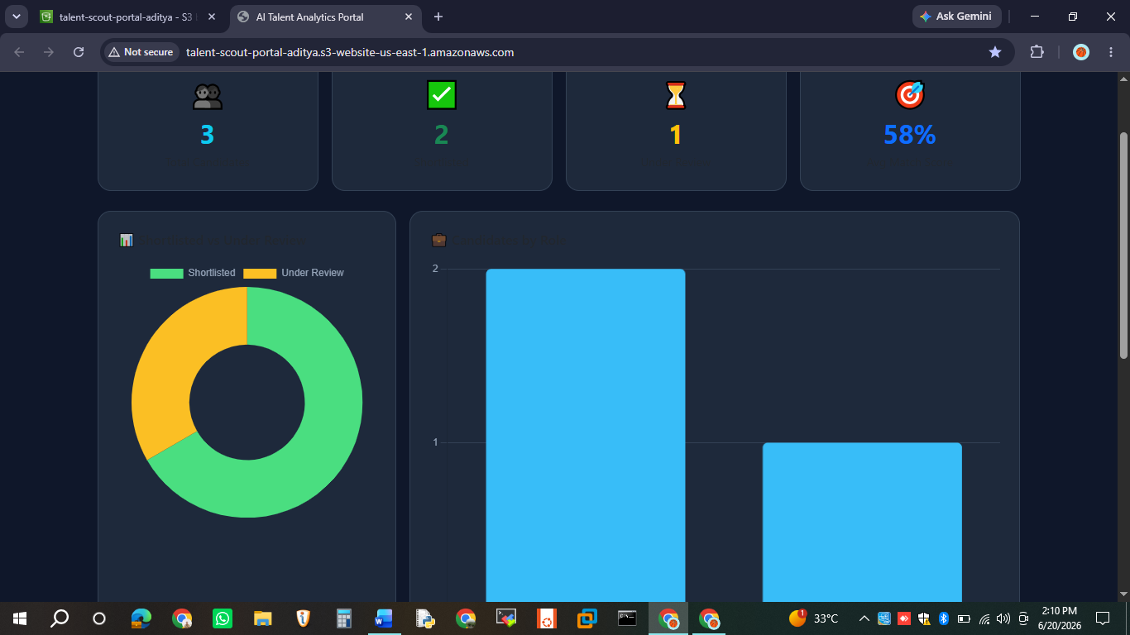

The Analytics Dashboard provides a comprehensive view of all candidates with:
• Total Candidates count
• Shortlisted vs Under Review breakdown
• Average Match Score
• Donut chart showing status distribution

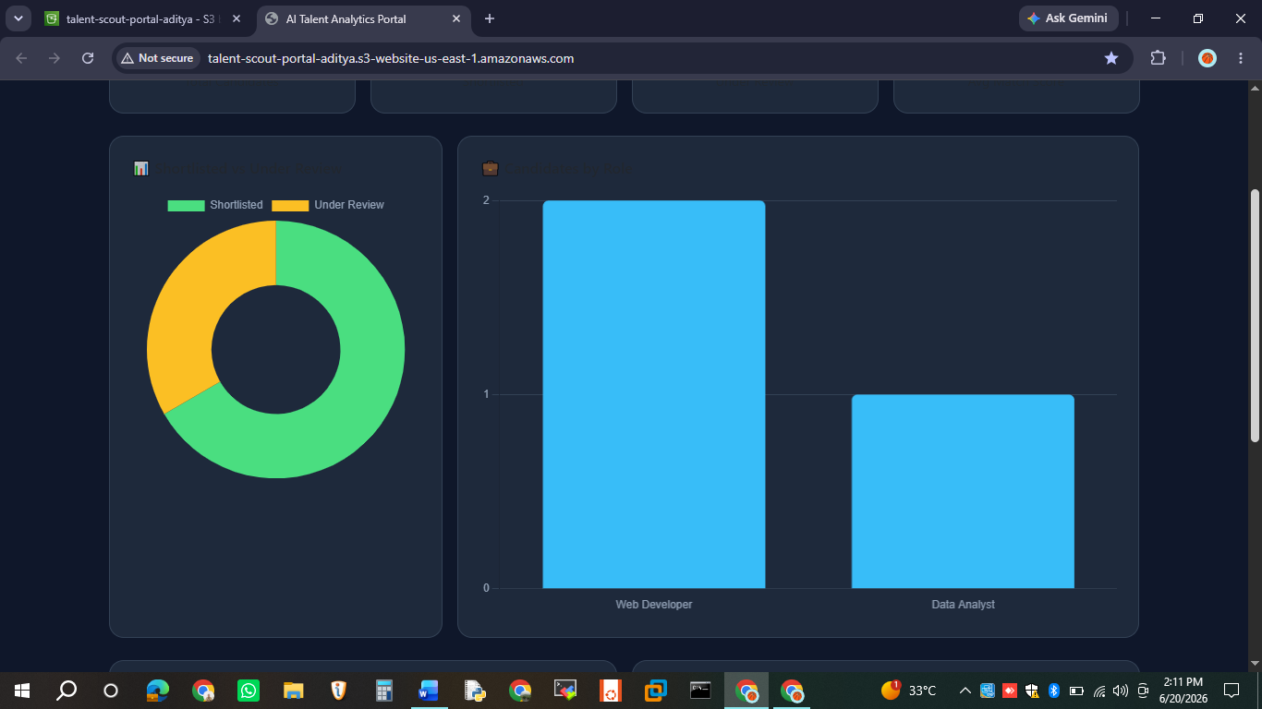

Additional analytics include:
• Bar chart showing candidates by job role
• Horizontal bar chart showing top skills distribution
• Score distribution histogram

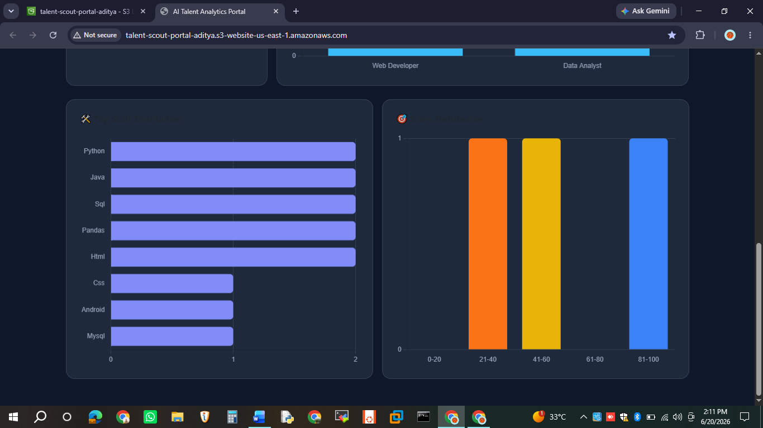

System Architecture
The complete system architecture:
• Frontend: HTML, CSS, JavaScript, Bootstrap 5, Chart.js hosted on AWS S3
• Upload Lambda: get-s3-upload-url-function generates presigned S3 URLs
• Processing Lambda: ai-resume-screener-function triggered by S3 upload event
• PDF Processing: Extracts text using Latin-1 decoding, regex for email/skills
• Email: AWS SES sends notifications to HR and candidates
• Storage: AWS S3 for both resumes and results JSON files

Features Summary
• Drag & Drop PDF Upload
• Auto Skill Extraction (20+ skills)
• Role Detection (8 job roles)
• Match Score (0-100%)
• Analytics Dashboard with Charts
• Email Notifications via AWS SES
• Auto-refresh on page load
• Search by name, skill, or role

